Curriculum Vitae | Name Last Name OLY | City, Country  +Phone number  your.name@olympian.org  Linkedin
 | Insert summary of your profile, strengths, interests. Be brief and impactful. i.e: A dedicated and passionate leader, I am goal-oriented, with strong interpersonal and creativity skills.
Olympic Games Attended | 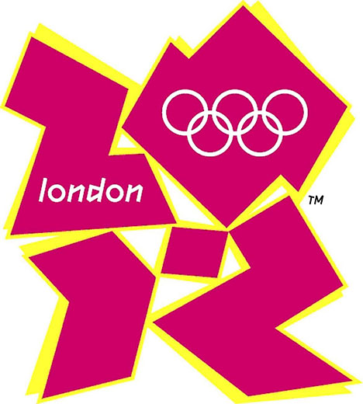  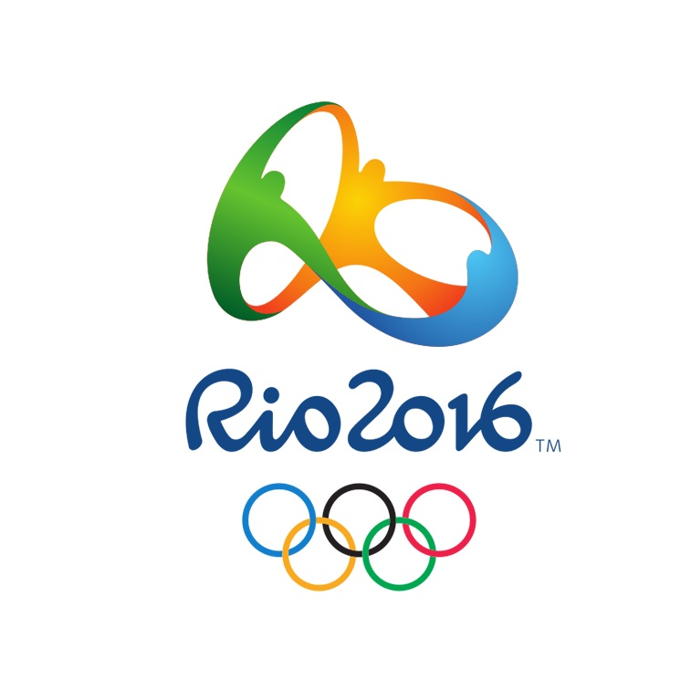  - Basketball athlete competing at national level and representing XXX country in XXXX regional/international/continental events  - Participated in tournaments in more than 10 countries with multiple international teammates  - Member of the national team for 5 years and the national club for 10 years.
Awards (if applicable) or Leadership /community activities | Awards  - Appointed to the IOC Athlete’s commission by the IOC President Thomas Bach.  - Ambassador of the XXX Foundation for a programme to bring sports (basketball) to young kids from vulnerable areas  Volunteer - Swimming World Championships, Country, Year  Role, Dates  Skills, achievements, responsibilities etc.
Education | 2016 – 2020 Bachelor in ……  Elite athlete. Sport xxxx  20012 – 2016 High school ….  Elite athlete. Sport xxxx
Experience | Organisation, Country (if applicable)  Position, Dates (Dec 2015 to present)  Skills, achievements, work responsibilities etc.  XXX Basketball team, Country  Junior coach and player for the team, September 2016 to present  - Organised weekend trainings for athletes, covering all scopes of the events from budget, scheduling coordination with athletes, event infrastructure, etc.  National league XXX Basketball Club, Country  Professional player  - Played team competitions for the club in the 1 Division of the basketball league.  Participated and led team-building events  Referees available upon request

